Yangon Technology University

Department of Electronic Engineering

**Design and construction of efficient Battery Management System**

Proposed supervisor-Dr . Myint Myint Than

By

Ma Ei Mon Soe

MEEC-5

Thesis Proporsal

August ,2018

**Contents**

No Title Pages

1. Introduction 3
2. Objective 4
3. Literature Review 5
4. Proposed Methodology 10
5. Applications 13
6. Conclusion 14
7. Time table 15
8. References 16

**Introduction**

Today, electronic devices are developed. A lot of batteries are connected in series or parallel to apply the devices. Battery is a devices that is convert the chemical energy to electrical energy. It is depend on temperature. There are two types of battery. The first is primary that is non rechargeable. And the second is secondary that is rechargeable. Batteries are used both the small applications such as laptop, mobile phone and etc., and large applications such as Electric vehicle, Solar Power Farm and etc. To get the desired voltage or capacity, a lot of batteries are connected in series or parallel. In this saturation, a lot of batteries can cause explosion and unbalance cell voltage .Battery Management System is needed in any applications that is connected in series or parallel.

**Objectives**

Battery Management System is a system that manage a lot of batteries connected in series or parallel. Moreover it is to protect the battery from damage and extend the battery life. And to get the balance voltage for each cells.

**Literature Review**

|  |  |  |
| --- | --- | --- |
| NO | Papers | Contents |
| 1 | Battery Management System | Functions and design |
| 2 | A look inside Battery Management System | Design |
| 3 | Battery Management System for electric vehicle | Functions and construction |

**Refer paper 1:**Use the Lithium Ion batteries, LCD, BQ76PL536 , MSP 430fr 5969

In this paper, the function of BMS is to monitor the cell status and to control the cell balancing .

**Figure 1: Block diagram of Battery Management system**

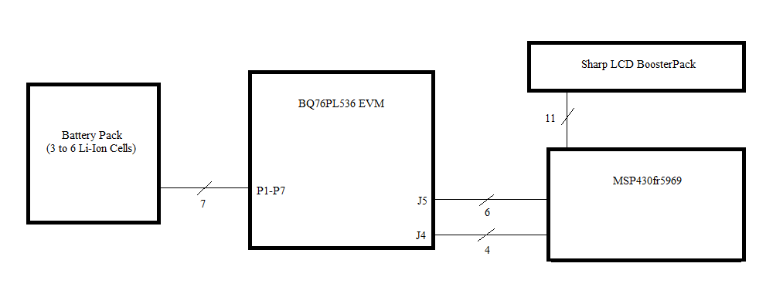

**Refer paper 2:**Describe the battery management system design and explain.

In this paper, BMS consist of five functional blocks. They are

1. Cutoff FET
2. Current Measurements
3. Cell voltage and Maximum battery lifetime
4. Temperature monitor and
5. State machines

Cutoff FET is used to predict the battery cell voltages current and temperature. Current measurements is used to measure the current while charging. Cell voltage and maximum battery lifetime is a part to get the balance voltage. Temperature monitor is to sense and display the temperature while charging and discharging. MCU is used as the state machines. ISL94203 is used in this paper .It is the analog front end that is offer the balancing and monitoring .

**Refer** paper **3:**In this paper , functions of BMS are

1. Discharging control
2. Charging control
3. State of charge determination
4. State of health
5. Cell balancing

The requirements are

* Hall effect sensor is used as the current sensor. LCD is used for display. For cell balancing , passive cell balancing is used.
* Passive cell balancing is a technique. It is used to find the highest charge in the pack and remove through the bypass resistor until the other cells are matched.

Figure 2: block diagram of battery management system :reference : BMS for electric vehicle applications

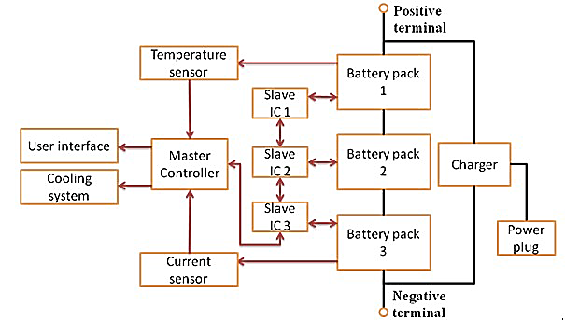

**Proposed Methodology**

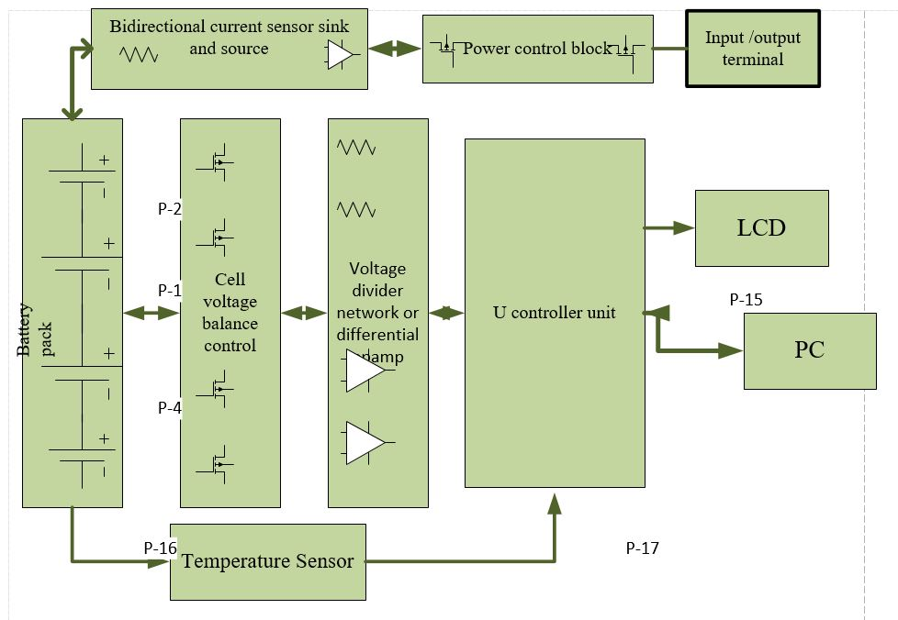

Fig 3: block diagram for BMS

There are a lot of functions in BMS depend on the applications. In this proposal, measuring, monitoring and control the cell are the focused functions.

**Requirements**

MOSFET or Transistor BJT, LCD, resistor voltage divider or differential Opamp, LM 35 or RTD and Arduino or PIC.

From the block diagram,

**Power control block** is used to prevent and cutoff where the current over charging and discharging and over or under voltage. Use the **bidirectional current** **sensor** to sense and measure the current .MOSFET or BJT is used for power control.

**Cell voltage monitor block** is measured the voltage of each batteries .Use the resistor voltage divider or differential opamp.

**Cell voltage balance block** is control the cell voltage while the batteries is charging and to get the balanced voltage .Using charging algorithm.

**Temperature monitor** is used to prevent from the over heating when the cell charged and discharged. Using LM35 or RTD.

**State Machine** is used to control all systems. Using the Arduino or PIC.

Figure :4 circuit diagram for Battery Management System

Reference: A look inside battery management systems

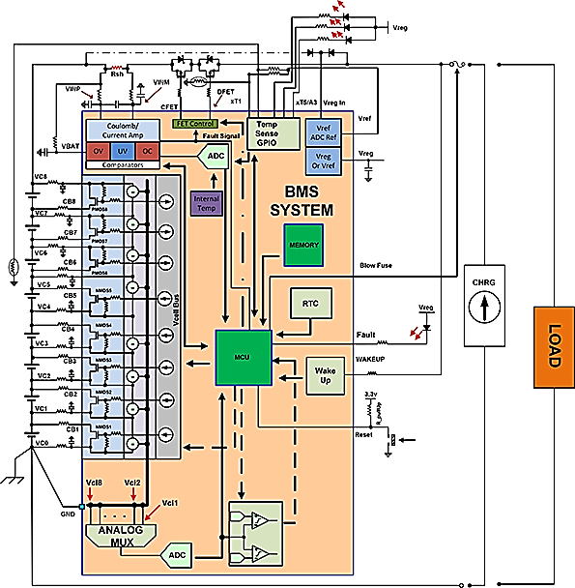

**Applications**

* Laptop battery
* Hi power UPS battery
* Electric vehicle
* Solar power farm

For example: Laptop battery has two parts. The first is the energy of battery in percentage and the second is the long life of battery usage.

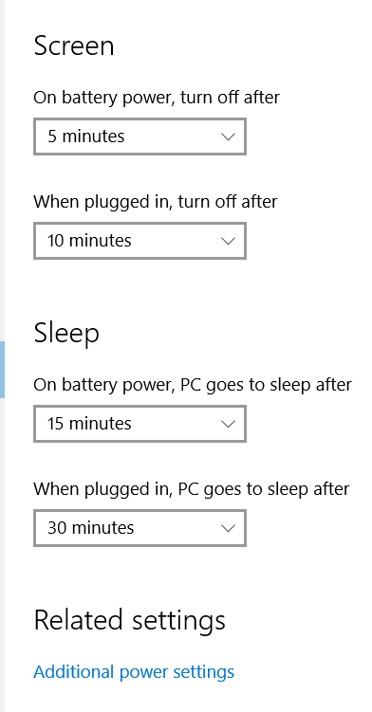

Figure 6:Laptop battery setting

**Conclusions**

Battery management system is the useful in the applications which is used of more than one batteries connected is series or parallel. To maintain the battery life and prevent the unbalance voltage. The aim of this proposal is to control and protect the battery status such as voltage, current, temperature and display how long time for charging.

**Time Table**

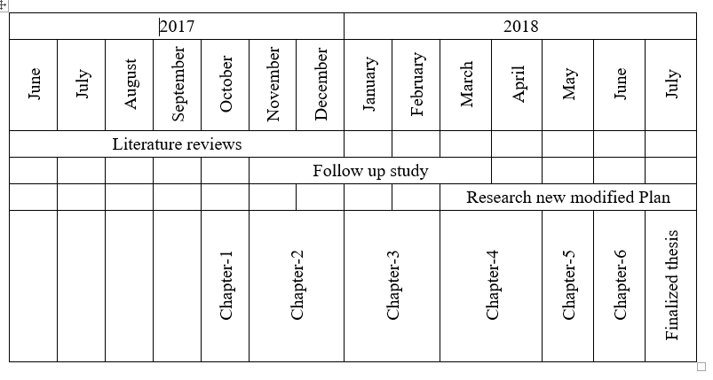

**References**

1. Michael DeSando , “Battery Management System”, Senior project design ,2014.
2. Ryan Roderick, “ A look inside Battery Management Systems” , Electronic Design, 2015.
3. Rui Hu, “Battery Management System for Electric Vehicle Applications”, University of Windsor,2011.
4. Jose Miguel Branco Marques, “Battery Management System for lithium ion batteries”, University of Coimbra ,2014.